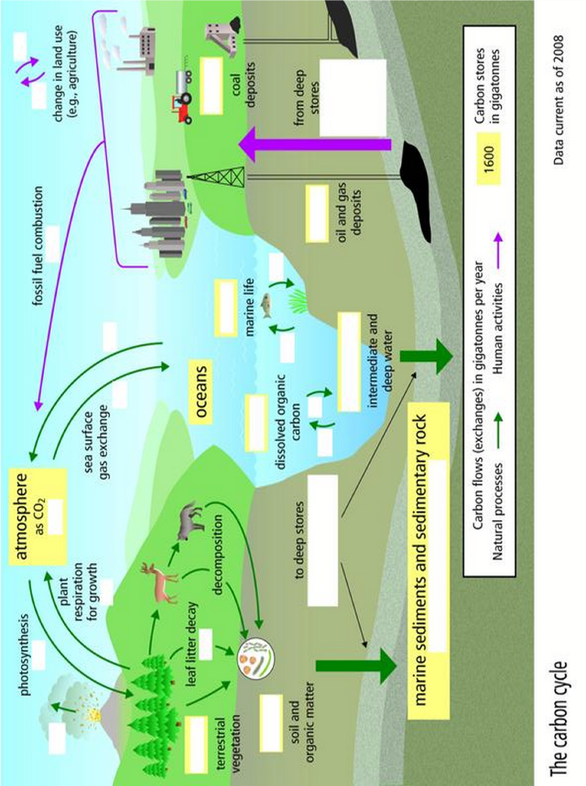
Carbon Cycle Worksheet
Information for these questions is on your carbon cycle diagram, and (more obviously) on the interactive carbon cycle at
https://fc.deltasd.bc.ca/~mannandale/sc10/hw/EP_carbon_cycle.swf
- Fill in all the missing information on the diagram above – the missing information is on the website. Your teacher will project this site on the board for you.
- Name all the places where carbon exists (nine):
a. d. g.
b. e. h.
f. g. i.
- List three roles that plants and trees perform in the carbon cycle on land:
a.
b.
c.
- How does carbon get from the atmosphere into fish and then into the ocean sediment? (think – food chain – not on the carbon cycle diagram)

- Can carbon get from the deep ocean back into the atmosphere? If yes, explain how.

- What are two major ways that humans affect the carbon cycle?
a.
b.
- (a) How many gigatonnes of carbon are exchanged from terrestrial vegetation to the atmosphere each year and what is this process called?

(b) How long does it take for carbon to be deposited into deep stores within marine sediments and sedimentary rocks?

(c) How long does it take for carbon to be removed from deep stores (usually by mining or drilling of oil and coal deposits)? Why is the time taken for this such an important factor in global warming?

(d) How much carbon is emitted into the atmosphere through fossil fuel combustion each year?

(e) How much carbon is exchanged between the oceans and the atmosphere each year?

**(f) Draw up a table in your book listing: the nine sites where carbon is stored, the amount of carbon in each, and the percentage of carbon stored in each.

